**Adriann Liceralde**

**EGI at University of Utah**

**August 6, 2021**

**Information for SCD-30 CO2 Sensor**

**Introduction**

* SCD-30
* Low cost
* Sensitive
* This sensor can be controlled by any microcontroller. This guide and the associative codes will use an Arduino Uno.

**Important Notes**

* This device is EXTREMELY sensitive to electrostatic discharge.
* NEVER touch the sensor UNLESS wearing Anti-Static Gloves.
* Even if the sensor is not connected to a power source, still exercise extreme caution.
* The sensor is sensitive to sunlight. DO NOT place in direct contact with sunlight.

**Links**

* Product Info: <https://www.sensirion.com/en/environmental-sensors/carbon-dioxide-sensors/carbon-dioxide-sensors-scd30/>
* Arduino Library: https://github.com/sparkfun/SparkFun_SCD30_Arduino_Library

**Wiring**

* To operate the sensor, a minimum of 4 pins are required to be connected to an Arduino:
  + VIN (Voltage Input)
  + GND (Ground)
  + SCL (Clock Line for I2C communication)
  + SDA (Data Line for I2C communication)
* The sensor can accept a voltage input range of 3.3V to 5.5 V.
* The I2C pins can have 5V, but are recommended to be 3.3 V.
* Therefore, the sensor can be hooked up by two ways

**Wiring – Method #1**

* The schematic below shows how to connect the Arduino to the SCD-30 board. The sensor is powered by 5V, and the SCL and SDA lines are at 5V.

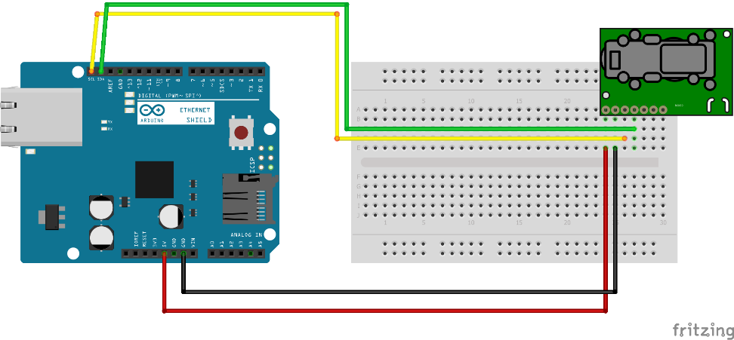

**Wiring – Method #2**

* The schematic below shows how to connect the Arduino to the SCD-30 board. The sensor is powered by 5V, but the SCL and SDA lines have been stepped down to 3.3V.

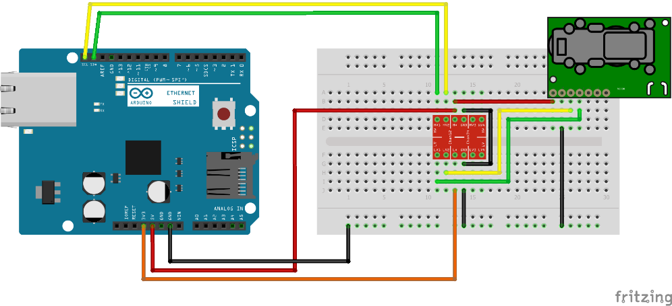

**Photos of Circuits**